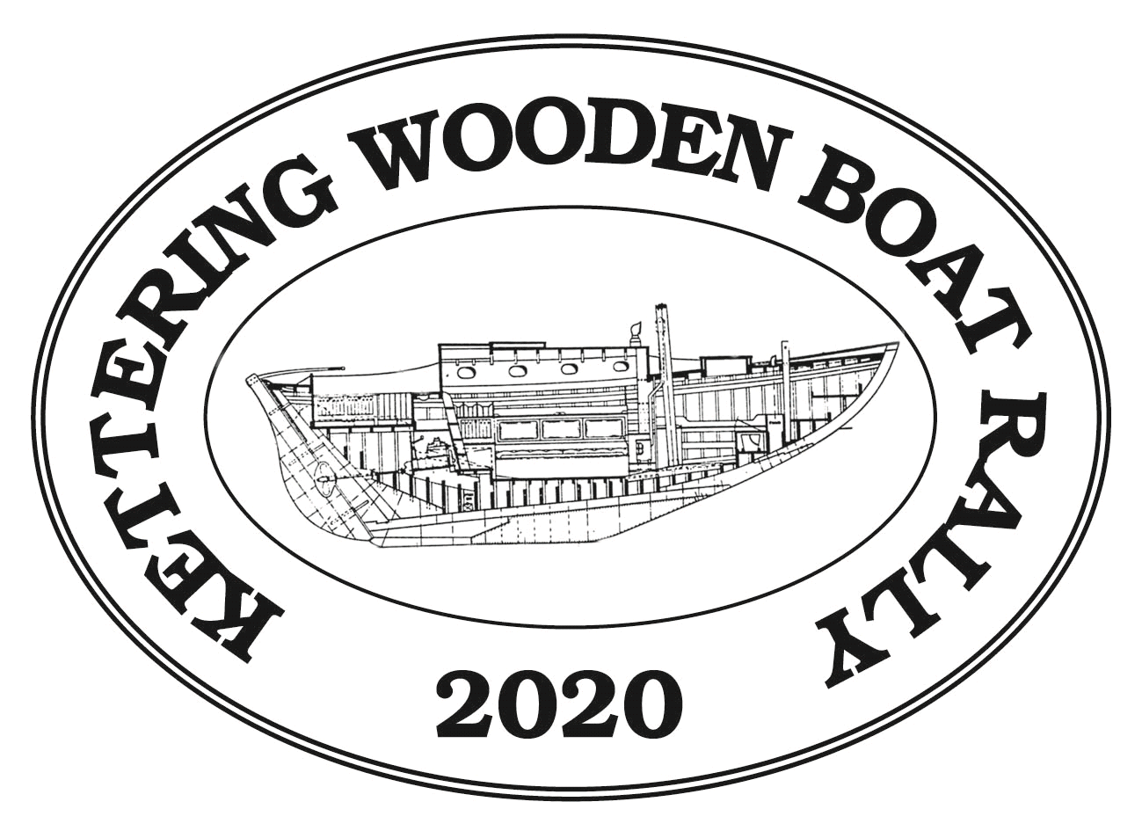

ENTRY FORM
2020 KETTERING WOODEN BOAT RALLY
Friday, Saturday & Sunday 7th - 9th February 2020

Please enter me in the Event(s) ticked below. Sailing vessels, motor boats, dinghies and canoes are welcome to join in the fun, but all participating vessels must have wood as their principal construction material.

Friday evening twilight event (also open to other non-wooden yachts)
Keel Yachts, (Saturday and/ or Sunday Event)
Rowing or paddled vessels, Sailing Dinghies
Motoring Boat Rally

Helmsman’s Name ______________________________________
Name of yacht/boat Sail Number ____________
Club (If Applicable)
Class or Type of Boat Year of Construction ____________
LOA ________________ Beam ________________ Draft ________________
Hull Colour ________________ Rig
Propeller Details (2/3 blade or folding) ____________ Other identifying features _____________________
By entering the Kettering Wooden Boat Rally on water events, and signing the following declaration, owners/skippers of all yachts are declaring that they meet AS Category 7 Safety Requirements and have a Third Party Liability Insurance Policy (minimum $5,000,000). Powered Vessels must comply with MAST safety requirements, and carry a Third Party Liability Insurance Policy (minimum $5,000,000).
Declaration for all entries: I agree to be bound by the current Racing Rules of Sailing (RRS) of the International Sailing Federation, and the Prescriptions and Special Regulations (SR) of Australian Sailing (AS) and the current sailing instructions published by the Kettering Yacht Club.
I acknowledge that AS Rule 4 Decision to Race places sole responsibility for deciding to participate in a race, or to continue racing, on the individual skipper.
Name: Signature: _____________________ Date:_________________



(Don’t forget to fill out page 2)

Owner/representative Contact Details:

Address:

Postcode

Home Telephone: Mobile:

Email:

Please supply a picture of your vessel. Photographs can be a good quality print included with your entry form or a digital image sent by email to kwbr@woodenboatguildtas.org.au. Photos will be displayed at KYC during the Rally.

Entry Fee: $25.00 if received before Friday 31st January 2020; Late entry Fee $25.00

Social Events:
Please indicate the likely number of participants from your vessel taking part in any of the following:
Saturday Lunch at Peppermint Bay Hotel as part of the small boat rally (at own cost)
Saturday night dinner at Kettering Yacht Club (cost $20.00/ person Pay at venue)
Sunday night dinner and presentation night at Kettering Yacht Club (cost $35.00/ person Pay with Entry)
Number of participants attending Sunday night dinner that require vegetarian meal
The Saturday night dinner will be an Indian Curry buffet and the Sunday night dinner will be a 3 course Roast Dinner. There may be limited places available for the Sunday night function.
Berths in the marinas at Kettering are very limited and the committee will coordinate with the marina to see if a berth can be provided if required. (First come first served). If you will require a berth at Kettering on Friday, Saturday or Sunday night, circle one or more: Friday Saturday Sunday
Entry Forms should be forwarded by 31st January 2020 to: Kettering Wooden Boat Rally 6
Care of Kettering Post Office
Kettering Tas 7155

The Committee may accept late entries, after 31st January and up to Saturday 8 February. A late fee of $25 will be levied.

Please include a cheque for the entry fee with your entry form. Payment can also be made by direct deposit: Account name – Kettering Wooden Boat Rally, BSB 06 7105, Account Number 10352221.
Please identify your payment by name. Cheques should be made payable to Kettering Wooden Boat Rally.

Payment for the Saturday Night Dinner will be at the venue (Kettering Yacht Club) on the weekend of the event and Sunday Night Dinner with entry registration. Places at the dinners will be limited because of the venue's capacity. Tickets will be sold on a first-come first served basis.






